Determination of Resultant Forces
If several forces, each having different magnitudes and directions, act on a point object, their net effect can be represented by a single force called a resultant force. The magnitude and direction of the resultant force can be found using a special process known as vector addition. Vector addition can be done both analytically and graphically. In addition, resultant force vectors can be found experimentally.
Objective
The purpose of this lab is to gain experience in working with vector quantities. The lab demonstrates the process of combining several vectors using various vector addition techniques to form a single resultant vector. Experimental, graphical, and analytical methods will be used to determine the resultant of several vector combinations.
Background
The addition of two vectors A and B is shown in the diagram at the right. Using the “head-to-tail” method, we first draw vector A by placing its tail at the origin of the coordinate system. Next, we draw vector B by placing its tail at the tip of vector A. The resultant vector R = A + B is found by drawing a straight line from the tail of vector A to the tip of vector B. The magnitude of R is proportional to its length and the direction in which it acts is the angle it makes with the horizontal.
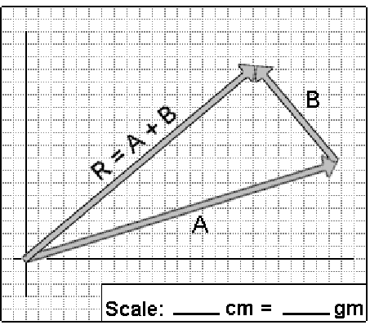
In the analytical process of vector addition, each vector to be added is first broken down into its x and y components. The components along each axis are then added algebraically to obtain the components of the resultant vector along each axis. This leads to the following:
RX = AX + BX = Acosθ1 + Bcosθ2
RY = AY + BY = Asinθ1 + Bsinθ2
The magnitude of the resultant vector is then found using the Pythagorean Theorem
$\left|R\right|$ = $\sqrt{R_{X}^{2}}+R_{Y}^{2}$
Furthermore, the angle θ that the resultant R makes with the x axis is given by the following:
Ɵ = arctan $\frac{R_{y}}{R_{x}}= \tan^{-1}\frac{R_{y}}{R_{x}}$
Since a nonzero resultant force accelerates an object, another force must be applied to establish equilibrium. If FA and FB are two known forces (represented by vectors A and B) applied to an object, they will have a resultant force (represented by the vector R). A force equal in magnitude and opposite in direction to R must be applied to keep the object in equilibrium. The force needed to establish equilibrium is called the equilibrant force.
The resultant force R is found experimentally by first finding the equilibrant force E needed to balance all the individual forces. The resultant force is then the force having the same magnitude as the equilibrant force E but acting in the opposite direction. A device known as a force table is used find the resultant force experimentally.
Equipment
- Force table
- Weights
- Protractor
- Measuring scale
- Calculator
- Bubble level
A force table was used to experimentally determine the resultant of several forces acting on a ring located at the center of the table. The magnitude of each pull was varied by adjusting the masses attached to the strings and the location of the pulleys on the rim of the table.
Part 1: Experimental method
The pulley was placed at the 0º mark on the force table and a mass of 120 gm on the end of the string. A second pulley was placed at 90º mark and a total of 80 gm placed on the end of the string. By trial and error, the angle at which a balancing force must act in order to place the ring in equilibrium was determined. A pulley was placed at this angle and a string passed over the pulley, the hanger was attached to the end of the string, and mass added to the disk until the ring was in equilibrium.
The experimental angle and amount of mass needed to balance the other two forces was recorded in the data table below. The resultant force R was determined and recorded based on the experimental results for the equilibrium force E.
Experimental Determination
Force | Angle | Mass
1 | 0 | 120
2 | 90 | 80
Equilibrium | 56 | -2.0
Resultant | 236 | 2.0

Part 1: Graphical Method
The arrows representing the forces F1 and F2 described above were drawn using a graph paper, a protector and a centimeter scale. A scale was chosen and each force vector drawn such that its length was proportional to the magnitude of the force. The direction of each arrow was the same direction as the force it represents. The head to tail method was used, the arrow that represents the resultant of two vectors was drawn to represent the resultant. From the length of the resultant vector R, the magnitude was determined according to the scale. The resultant vector’s direction was determined using the protector and the results recorded in the table below.
Graphical determination
Force | Angle | Mass | Length
1 | 0º | 120gm | 6.0cm
2 | 90º | 80gm | 4.0cm
Resultant | 56º | 146gm | 7.30cm
Scale: 1cm = 20gm
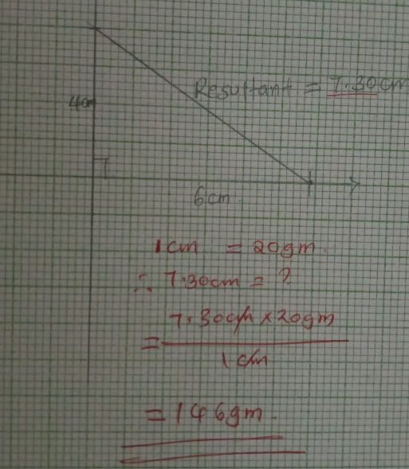

Part 1: component Method
The x and y components of F1 and F2 were determined using a calculator. Remembering Fx = FcosƟ and Fy = F sinƟ the x and y components of the resultant were found from the sum of x and y components. The magnitude of the resultant force from the square root of (Rx² + Ry²) and the direction of the resultant force from Ɵ_{R} = tan⁻¹ (R_{y}/R_{X}) was calculated.
Component Determination
Vector | Magnitude | Direction | X - Component | Y - component
1 | 1.2 | East | 1.03 | 0.6
2 | 0.51 | North west | 0.9 | 0.9
 |  |  | R_{x} = 1.95 | R_{y} =1.5

Resultant R = 1.30 Ɵ_{R} = 66.97º

Part 1: Error Determination
Experimental Error = $\left|\frac{experimental value-calculated value}{calculated value}\right|$ × 100%
= $\left|\frac{1.44-1.3}{1.3}\right|$ × 100%
= 10.94%
Graphical Error = = $\left|\frac{experimental value-calculated value}{calculated value}\right|$ × 100%
= $\left|\frac{1.44-7.3}{7.3}\right|$ × 100%
= 80.03%

Parts 2,3 and 4
The steps in part 1 were repeated to determine the resultant of thee three additional force combinations (2, 3 and 4) as shown below using the (1) experimental, (2) graphical, and (3) component methods for each combination of the vectors.
Force combination
 | Vector | Magnitude | Direction | Vector | Magnitude | Direction
2 | A | 175gm | 60º | B | 130gm | 160º
3 | A | 110gm | 145º | B | 140gm | 230º
4 | A | 150gm | 45º | B | 180gm | 290º

Part 2: experimental method
Using the force table, the forces in part 2 were described and the magnitude and direction of their resultant were experimentally determined. The results were recorded in the table below.
Experimental Determination
Force | Angle | Mass
1 | 60º | 175gm
2 | 160º | 130gm
Equilibrium | 53º | -3.05
Resultant | 233º | 3.05

Part 2: Graphical Method
Using the graph paper, the vectors that represent each of the two forces from part e were drawn along with their resultant force. The magnitude of the resultant in grams were determined and in its direction in degrees.
Graphical determination
Force | Angle | Mass | Length
1 | 60º | 175gm | 1.75cm
2 | 160º | 130gm | 1.30cm
Resultant | 53º | 250gm | 2.5cm
Scale: 1cm = 100gm
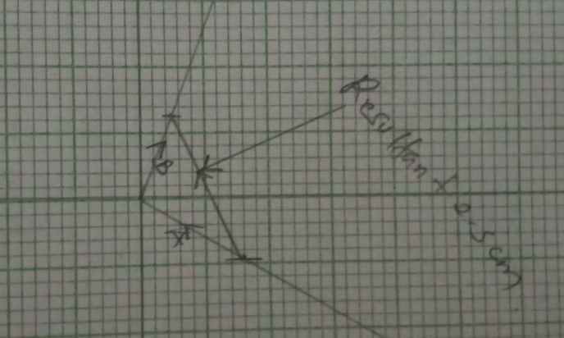
Part 2: Component Method
Component Determination
Vector | Magnitude | Direction | X - Component | Y - component
1 | 1.50 | North west | 0.88 | 1.22
2 | 1.58 | South west | 1.52 | 0.44
 |  |  | R_{x} = 2.4 | R_{y} =1.66

Resultant R = 2.92 Ɵ_{R} = 34.67º

Part 2: Error Determination
Experimental Error = $\left|\frac{experimental value-calculated value}{calculated value}\right|$ × 100%
= $\left|\frac{3.05 -2.92}{2.92}\right|$ × 100%
= 4.45%

Graphical Error = = $\left|\frac{experimental value-calculated value}{calculated value}\right|$ × 100%
= $\left|\frac{3.05 -2.5}{2.5}\right|$ × 100%
= 22.0 %

Part 3: Experimental Method
Experimental Determination
Force | Angle | Mass
1 | 145º | 110gm
2 | 230º | 140gm
Equilibrium | 51.84º | -2.50gm
Resultant | 231.84º | 2.50gm

Part 3: Graphical Method
Graphical determination
Force | Angle | Mass | Length
1 | 145º | 110gm | 1.1cm
2 | 230º | 140gm | 1.4cm
Resultant | 38º | 180 gm | 1.8cm
Scale: 1cm = 100gm
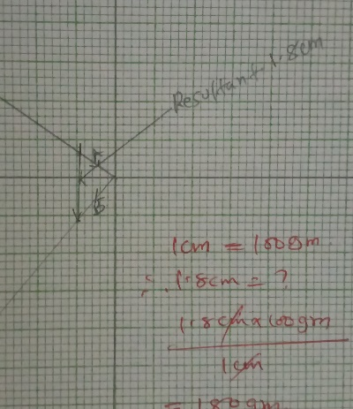

Part 3: Component Method
Component Determination
Vector | Magnitude | Direction | X - Component | Y - component
1 | 1.17 | North east | 0.74 | 0.90
2 | 1.24 | South west | 0.63 | 1.07
 |  |  | R_{x} = 1.37 | R_{y} = 1.97

Resultant R = 2.40 Ɵ_{R} = 55.18º

Part 3: Error Determination
Experimental Error = $\left|\frac{experimental value-calculated value}{calculated value}\right|$ × 100%
= $\left|\frac{2.5 -2.40}{2.40}\right|$ × 100%
= 4.1%
Graphical Error = $\left|\frac{experimental value-calculated value}{calculated value}\right|$ × 100%
= $\left|\frac{2.5 -1.8}{1.8}\right|$ × 100%
= 38.89%
Part 4: Experimental Method
Experimental Determination
Force | Angle | Mass
1 | 45º | 150gm
2 | 290º | 180gm
Equilibrium | 50º | -3.3
Resultant | 230º | 3.3

Part 4: Graphical Method
Graphical determination
Force | Angle | Mass | Length
1 | 45º | 150gm | 1.5cm
2 | 290º | 180gm | 1.8cm
Resultant | 39.80º | 270gm | 2.7cm
Scale: 1cm = 100gm
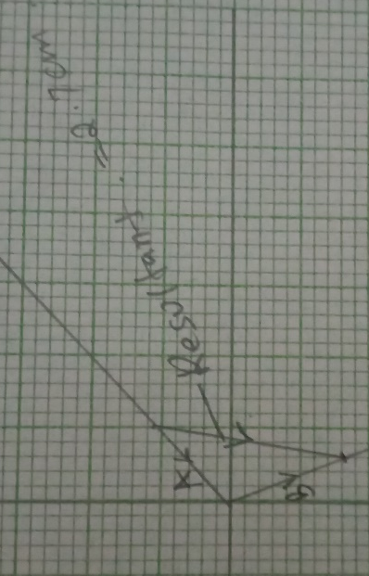
Part 4: Component Method
Component Determination
Vector | Magnitude | Direction | X - Component | Y - component
1 | 1.23 | North east | 1.06 | 0.62
2 | 1.99 | South east | 1.06 | 1.69
 |  |  | R_{x} = 2.12 | R_{y}=2.31

Resultant R = 3.14 Ɵ_{R} = 47º

Part 4: Error Determination
Experimental Error = $\left|\frac{experimental value-calculated value}{calculated value}\right|$ × 100%
= $\left|\frac{3.3 -3.14}{3.14}\right|$ × 100%
= 5.09%

Graphical Error = $\left|\frac{experimental value-calculated value}{calculated value}\right|$ × 100%
= $\left|\frac{3.3 -2.7}{2.7}\right|$ × 100%
= 22.22%

Data summary Table
 |  |  |  |  | Resultant Determination Method
 | Force A |  | Force B |  | Component |  | Experimental |  |  | Graphical
 | mass | Ɵ | Mass | Ɵ | Mass | Ɵ | mass | Ɵ | % Error | Mass | Ɵ | % error
 | 120gm | 0º | 80gm | 90º | 130gm | 66.97º | 200gm | 66º | 10.94 | 146gm | 56º | 80.03
 | 175gm | 60º | 130gm | 160⁰ | 292gm | 34.67º | 305gm | 53º | 4.45 | 250gm | 53º | 22.0
 | 110gm | 145º | 140gm | 230º | 240gm | 55.18º | 205gm | 51.84º | 4.10 | 180gm | 38º | 38.89
 | 150gm | 290º | 180gm | 290º | 314gm | 47.00º | 330gm | 50º | 5.09 | 270gm | 39.8º | 22.22

Questions
- Suppose three forces, each having different magnitudes, are in equilibrium on the force table. Will they still be in equilibrium if you add an equal amount of mass to all three of the weight hangers? Why? (Hint: Use the force table and your setup from Part 1 to justify your answer. After establishing equilibrium, add 50 gm to all three weight hangers and describe what happens.)
Yes they will be in equilibrium but the direction of the forces will change since the equilibrium is only affected by the in balance of forces.
- If D is the vector that balances the effect of vectors A, B, and C all acting together, which vector will balance the effect of vectors A, C, and D all acting together? (Note: vectors A, B, C, and D are in equilibrium.)
Vector B be will balance A, C and D because all the vectors A,B,C and are in equilibrium.

- A child weighing 200 N is being held back in a swing by a horizontal force of 125 N. Use the graphical method to determine the tension T in the rope and the angle θ that the rope makes with respect to the horizontal. Include the graph in your lab report.
Using graphical method, the height h is equivalent to the reaction force, therefore, the tension in the string will be the resultant force.
Ɵ = tan⁻¹ $\frac{200}{125}$
= 57.99º
Hence
T =$\sqrt{{200}^{2}+ {125}^{2}}$
T = 235.84

- While tying his shoes, a person holds the shoestrings at the angles indicated in the illustration below and pushes downward with a force of 20 lbs. Use the component method to determine the tensions T1 and T1 in each shoestring.

20lbs = 9.07185kg
Using the component method T₂sin 40 = 9.07185 × 10
Therefore T₂ =$\frac{90.7185}{\sin{40}}$
= 141.13 N
T₁ = $\frac{90.7185}{\sin{30}}$
T₁ = 181.437 N
- The two ropes supporting the hammock shown in the illustration below are both tied to the trees at the same height. At what angle θ will the tension T in each rope be equal to the person’s weight. In other words, at what angle θ does Tension = mg? (Hint: Use the force table to find the angle θ by placing three equal masses on the three strings. Position one of the masses (representing the person in the hammock) at 270O and position the other two masses (representing the tension in the ropes) at the angles that establish equilibrium.)
At Ɵ =45 the tension = mg this value is according to the values in the table.

